EJ Cervantes
Gary Lewandowski
CSCI 240
25JAN2019

Homework 1
1)
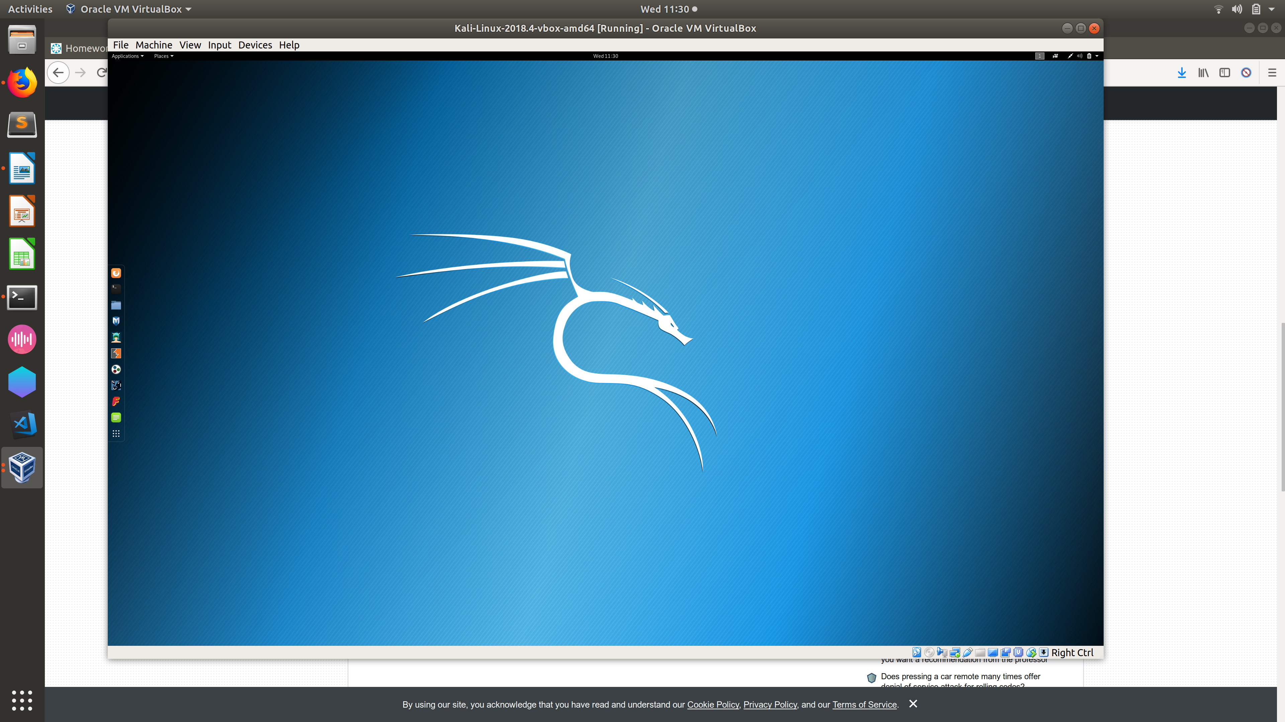
2)

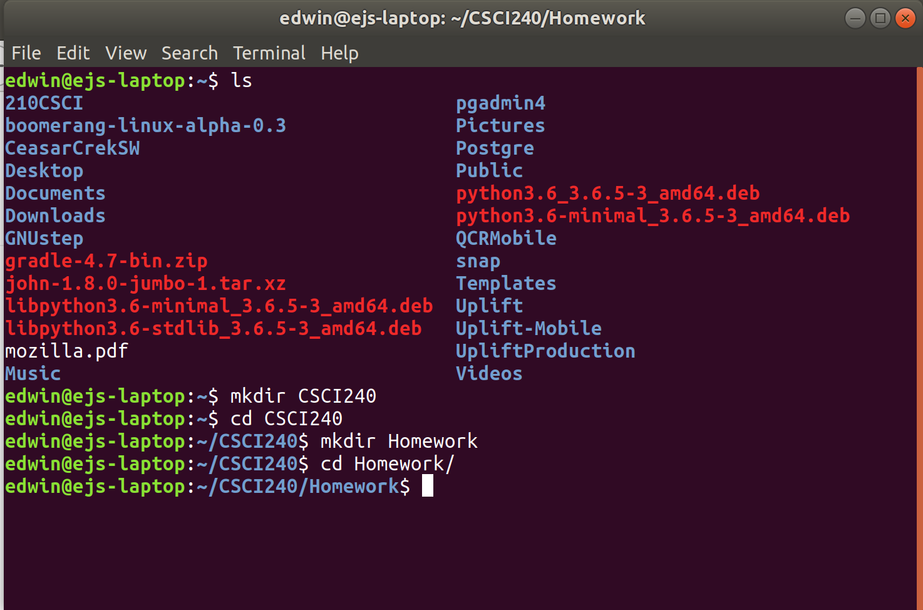

3)

F) CD stands for change directory so I’m not to sure what this question is asking..
G) Type cd and enter to return to home directory or cd.. to return to previous directory
H) Writes path name of the directory you are currently sitting in
I) ls shows all files while ls -a shows all hidden files as well.
J) ls -F, according to the man pages, classifies what kind of node it is
L) Creates a .txt file containing the contents of whatever is in the parenthesis
S) Prints contents of .txt file to terminal
T) cat brings it to the terminal and does not need you to quit while less requires you to quit the view.

U-X) I accessed my Kali VM through SSH because I hate typing on the tiny terminal inside the machine GUI(I have the GUI if needed). So because of the SSH I received an output of
Error: no DISPLAY environment variable specified
When Firefox is started through the terminal you are executing a job on that terminal and can only do one job at a time per terminal. So one must stop the job before you can use that terminal again. Once suspended you cannot use Firefox anymore and may possibly force quit on you. You can use Firefox after using the bg command on a suspended job. The & command does what basically the bg command does except without needing to suspend the job first.
Y) Potential has a shelf life, schrodinger's cake is sometimes a lie

